1. Floor in sorted array

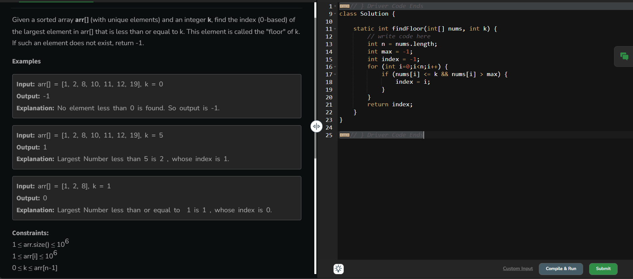

Time complexity: O(n)

2. Check equal arrays

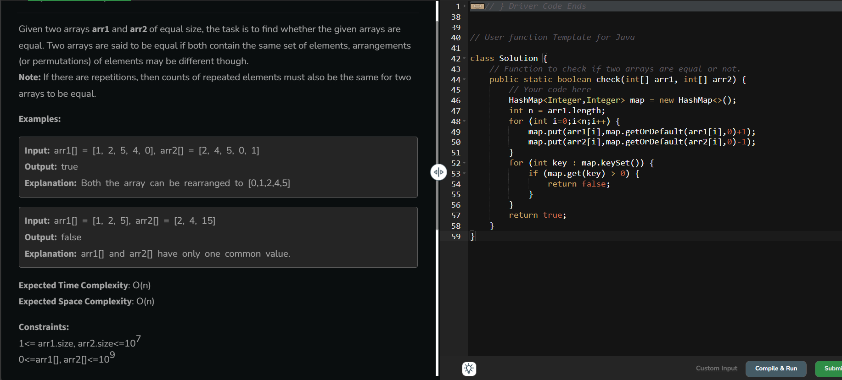

Time complexity: O(n)

3. Palindrome Linked List

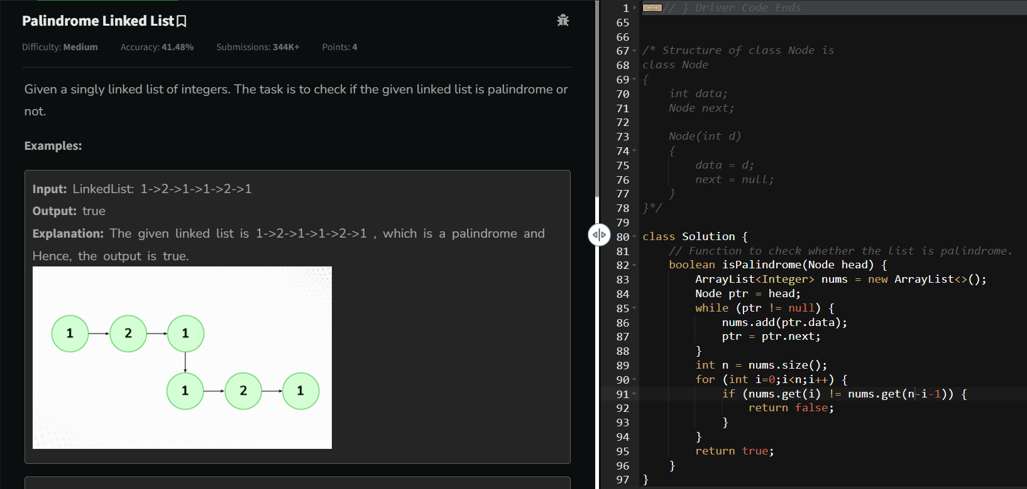

Time complexity: O(n)

4. Balanced tree check

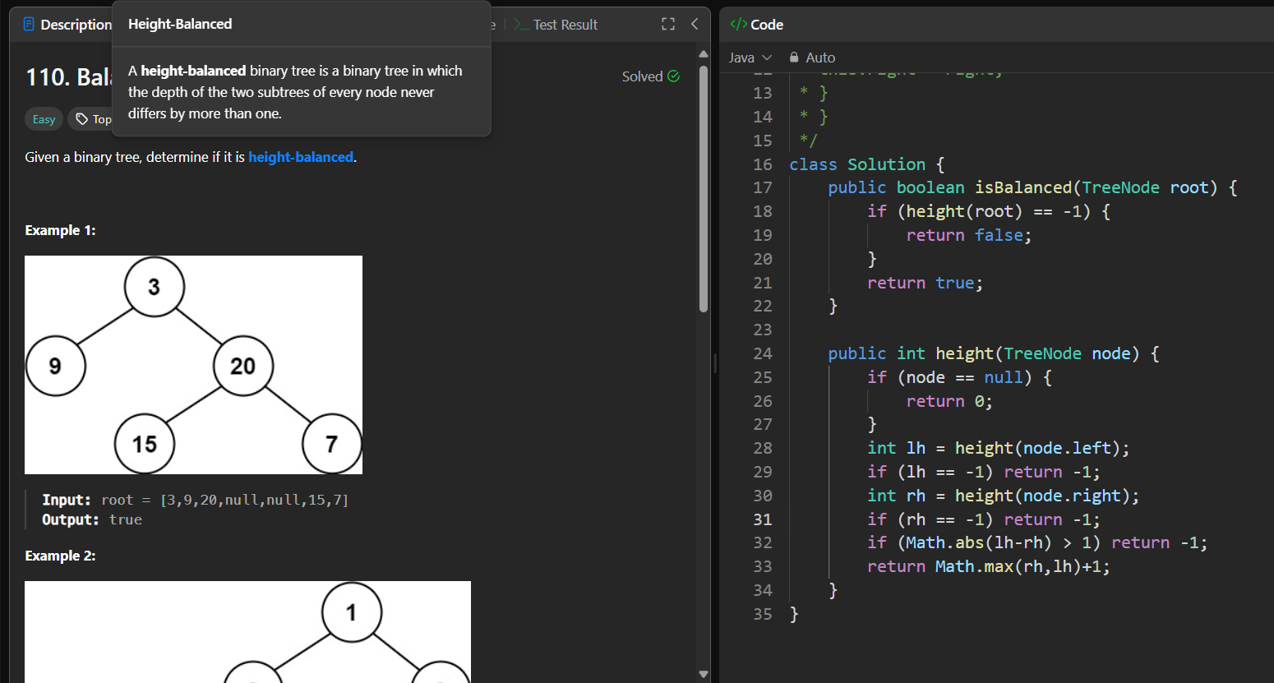

Time complexity: O(n)

5. Triplet sum in array

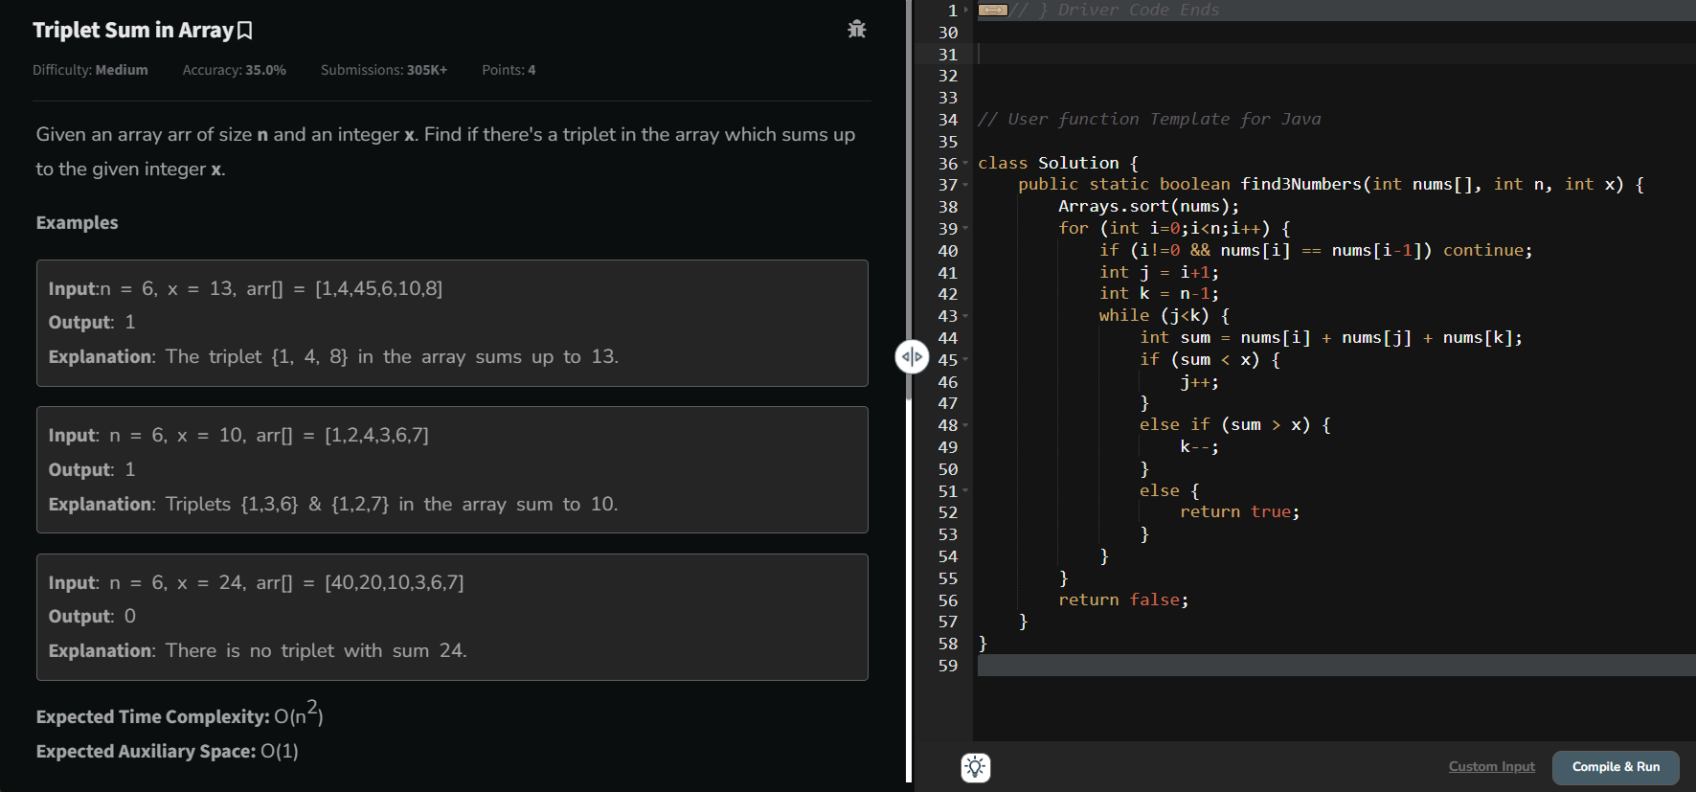

Time complexity: O(n^2)

6.

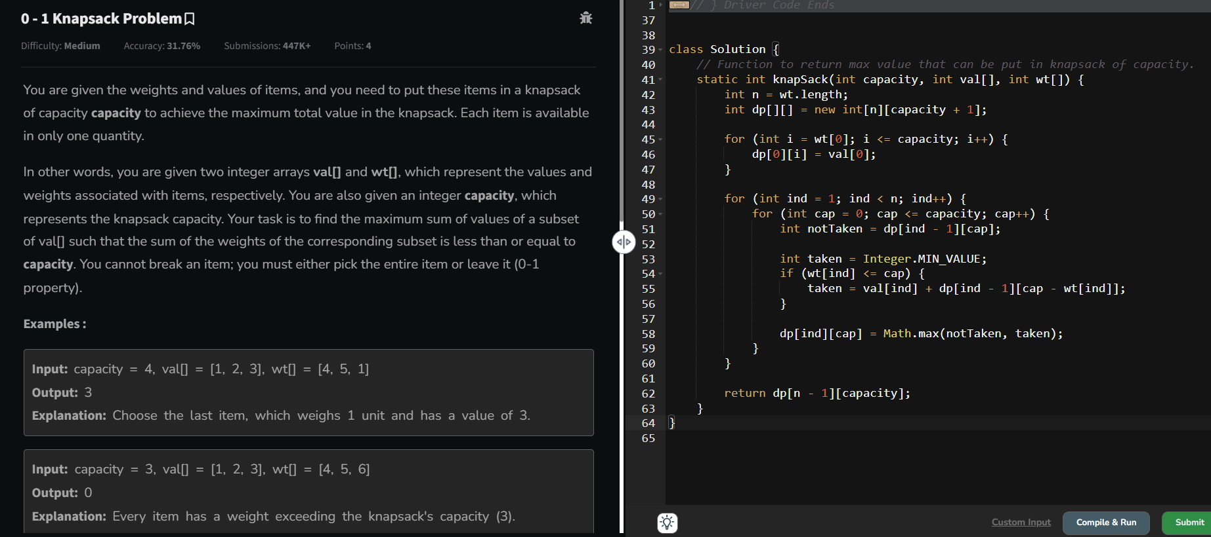

Time complexity: O(n\*capacity)